5145 Copper Creek Drive
Pleasant Hill, IA 50327
Phone: 540-729-0619
Fax: 515-264-0296
E-mail: reisiminger@jts-llc.com

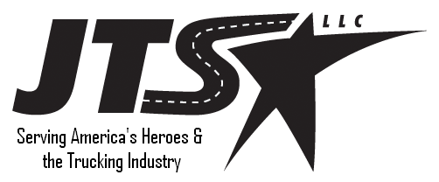
Phone: 540-729-0619

Transition Consultants

Quality Jobs, Top Companies
JTS-LLC.
Serving America’s Trucking Industry and America’s Heroes

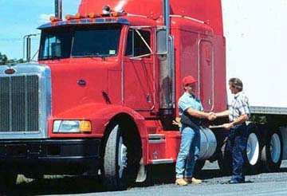
JTS-LLC.

We specialize in recruiting for the Trucking Industry.
Let us show you how to find a trucking job in the location of your choice.

You Deserve a Smooth Transition
There are thousands of trucking firms in the United States. Each has its own hiring requirements and restrictions as well as set domicile locations.
JTS-LLC will help you locate the company that wants you and your qualifications as well as placing you in the location you desire.

Thank You for Your Service

Let JTS-LLC Help You
Not every match is a perfect one. We offer counseling on how to improve your marketability to the industry before your separation. Drivers and Mechanics are needed across our great country. Let us help you by matching your needs and desires with the requirements of the industry.
What is the cost to you? Nothing except the time to fill out our application and to talk to our staff of transition specialists.

JTS-LLC Does the Leg Work
During a typical transition job search you would need to research firms domiciled in the location you wanted and request info and applications. JTS-LLC does this for you. After reviewing your JTS-LLC application, we provide you application kits for the company(s) that match your needs. We also provide information on the company so that you can make an informed decision. It is then between you and the company to reach a hire and acceptance decision.

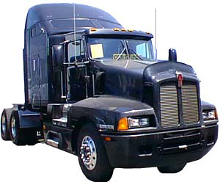


We are committed to providing you the smoothest transition possible. Please contact JTS-LLC to discuss your career requirements. Mr. Rick Eisiminger is available at 540-729-0619 or reisiminger@jts-llc.com for a free consultation.

