5145 Copper Creek Drive
Pleasant Hill, IA 50327
Phone: 540-729-0619
Fax: 515-264-0296
E-mail: reisiminger@jts-llc.com

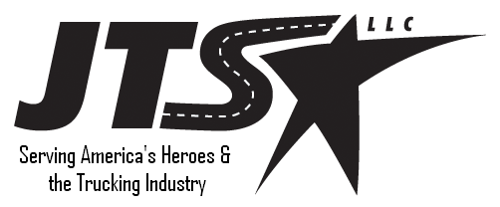
Phone: 540-729-0619

Transition Consultants

Quality, Experienced Drivers
JTS-LLC
Serving America’s Trucking Industry and America’s Heroes
JTS-LLC

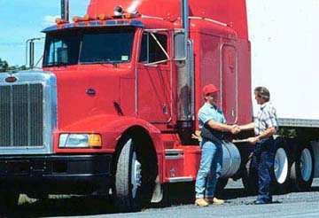
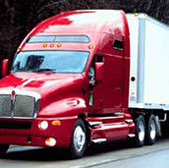
We specialize in recruiting for the trucking industry.
Let us show you how to benefit from our proven contacts in the military services.

Quality, Experienced Drivers
JTS-LLC can provide your firm with motivated drivers that are transitioning out of military service.
These prior service personnel have experience, maturity and proven work ethic that will add value to your company’s driving program.
Need mechanics? Let us know what your requirements are!
.

Fill Your Empty Cabs

What Are Your Empty Cabs Costing You?
Loads not executed due to driver shortages cost firms, on average, $2,500 per week in revenue per driver that could have been gainfully employed. How much is your driver shortage costing you?

An Alternate Approach
We don’t tap the traditional sources for drivers. Our pool is refreshed monthly as new service personnel prepare to transition to civilian life. These highly motivated men and women are eager to join the civilian workforce, bring talent and a great work ethic. We not only work to bring you and separating service member together but we provide transition counseling and guidance to effect a smooth move. What you gain from this is a great driver that is well adjusted to the new life and ready to hit the ground running on day one. Our separating service personnel are a great asset and worth investing in.
We are committed to customer satisfaction and delivering at a fair price. Please contact JTS-LLC to discuss your recruiting needs. Mr. Rick Eisiminger is available at 540-729-0619 or reisiminger@jts-llc.com for a free consultation.

